- Remove cargo pan, heat shields, and lower rear subframe.
- Rotate clutch cover snorkel rearward.
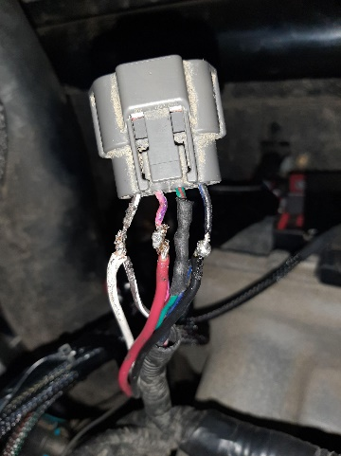
- Remove stock muffler.
- Cut header tubes at 2” from weld and remove collector.
- Remove airbox and air intake hose to plenum.
- Change injectors using supplied fuel rail spacers.
- Install brass vacuum nipple in place of set screw at throttle valve.
- Install Power Commander as per supplied instructions.
- Install Hurricane voltage clamp by connecting red to OEM map sensor pink.
- connect black into OEM map sensor black/blue.
- connect white wire into OEM map sensor grey/white
- Install oil supply fitting into front of head.
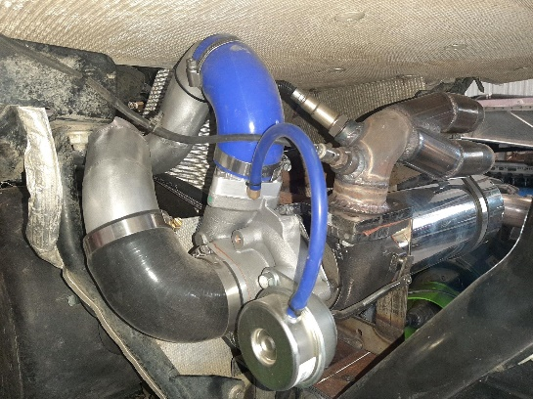
- Replace the valve cover oil fill plug with turbo oil return fitting.
- Set Hurricane turbo assembly in place and install frontward mount bolt and nut loosely to hold in place.
- Install oil return pump plate under turbo assembly and retain with supplied 2 bolts with stock nuts loosely.
- Route braided oil supply and rubber oil return hoses over clutch cover and fasten to fittings.
- Install charge tube from turbo to plenum.
- Zip tie oil hoses to charge tubes.
- Install muffler hangers as shown and 02 sensor by removing clip.
- Reinstall stock airbox and install air intake pipe from airbox to turbo mounting bolts.
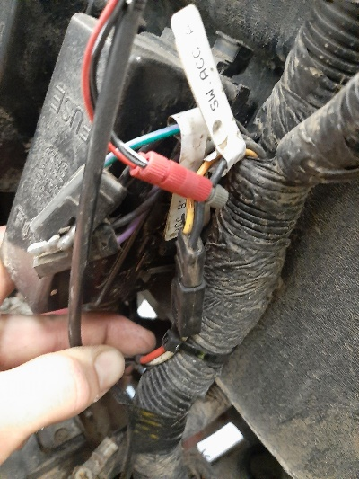
- Reinstall lower subframe and heat shielding.
- Route oil return pump wires under engine, along right side of subframe into cab console, through hole. Along with OEM wire harness
- Fasten wires as in picture to SW ACC connector
- Install clutch kit – Helix, clutch arms, and primary spring.
- Reinstall cargo pan and clutch cover.

